**Aim**: Perform CRUD (Create, Read, Update, Delete) operations in MongoDB using MongoDB Compass.

**Objectives**:

1. To understand and implement the basic CRUD operations in MongoDB.

2. To learn how to manage data efficiently in a NoSQL database.

3. To familiarize with MongoDB Compass for performing database operations visually.

Tools Used:

• MongoDB Community Server

• MongoDB Compass

**Concept**:

MongoDB is a NoSQL database that stores data in a flexible, JSON-like format called BSON. CRUD

operations represent the basic functions of persistent storage, essential for database management:

• Create: Adding new documents to a collection.

Example: Insert an employee’s record into the employees collection.

• Read: Retrieving documents from a collection.

Example: Query for an employee with a specific ID.

• Update: Modifying existing documents in a collection.

Example: Update the salary or position of an employee.

• Delete: Removing documents from a collection.

Example: Delete an employee’s record based on their ID.

MongoDB uses collections instead of tables and documents instead of rows, making it highly scalable and

flexible for unstructured or semi-structured data.

**Problem Statement**:

To implement CRUD operations in MongoDB

**Solution**:

Creating database

1. Open MongoDB Compass and connect to your database.

2. Select the database where you want to create the collection, or create a new one. o For

example, let’s name the database practical10.

3. Once you’re in the database, click on Create Collection in the top right corner.

4. Name the collection, e.g., employee.

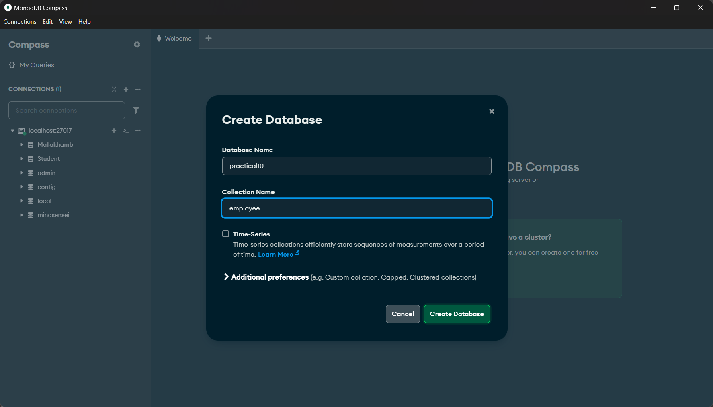

Now, let’s add the Create operation data.

Data:

{

"emp_name":"ABC",

"age":20,

"emp_email":"abc@gmail.com"

}

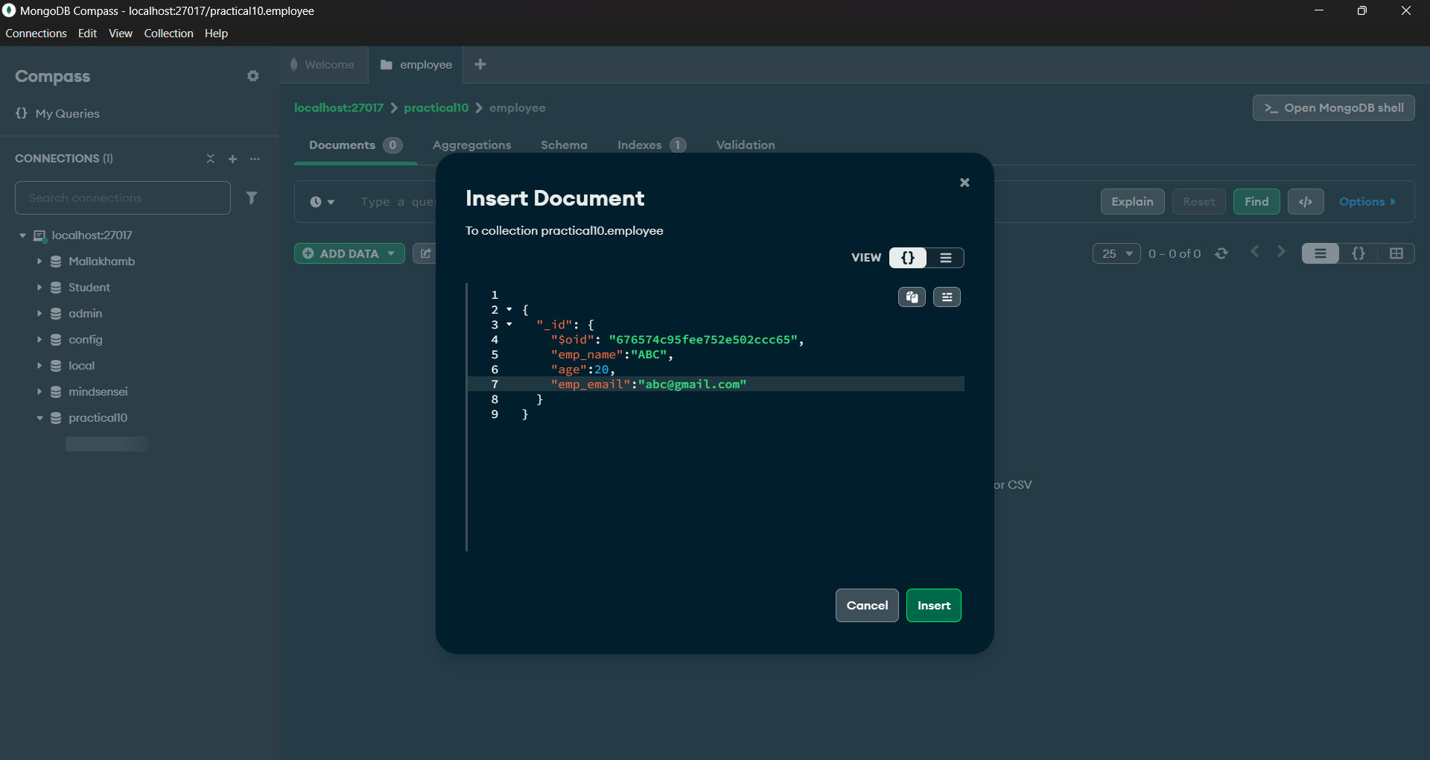

Create Operation:

1. Go to the employee collection in MongoDB Compass.

2. Click on Insert Document at the top of the collection view.

3. A modal will appear where you can paste the following data:

Click Insert to insert the document into the collection.

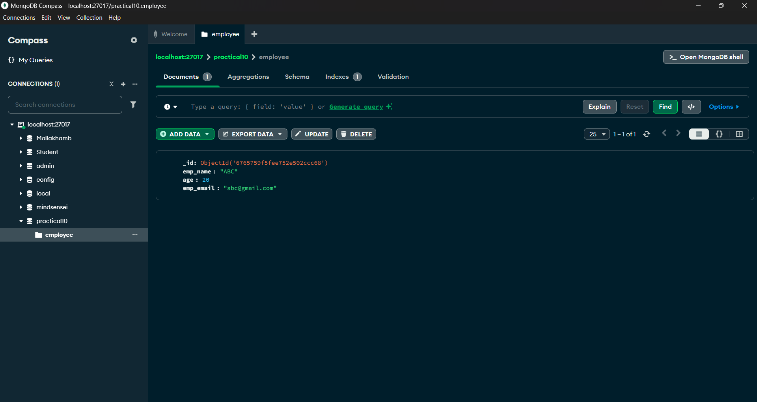

Read Operation:

1. Open MongoDB Compass and navigate to the employees collection within the companyDB database.

2. In the Filter box (found at the top of the collection view), enter the following query to find the document

with emp_name : ABC

1. Press Enter or click the Apply button to execute the query.

2. MongoDB Compass will display the document:

Update Operation:

1. Navigate to the employee collection within the practical10 database.

2.Locate the document you want to update by using the Filter box.

3. Once the document is displayed, hover over it and click the Edit Document button (pencil icon).

4. Modify the fields you want to update.

After updating

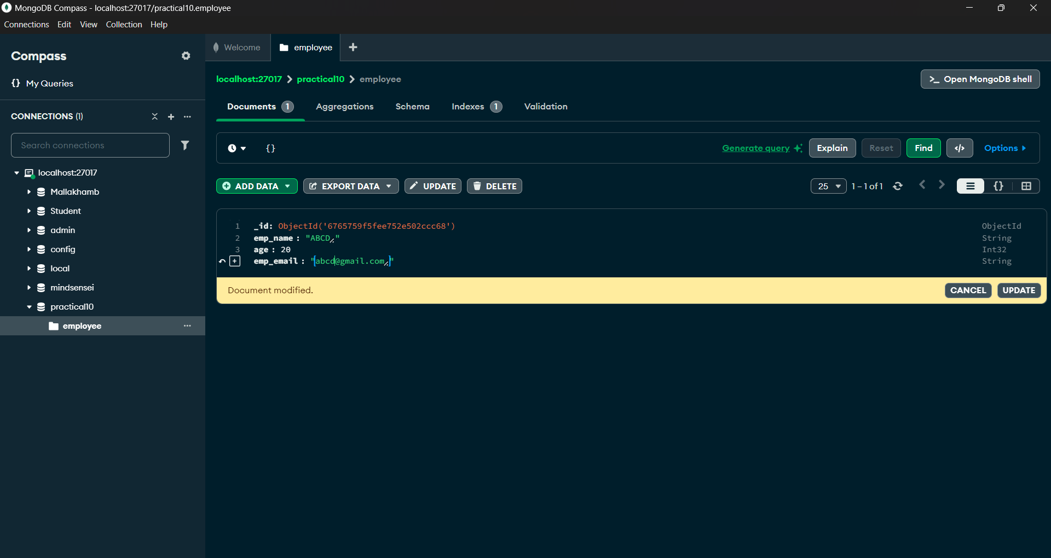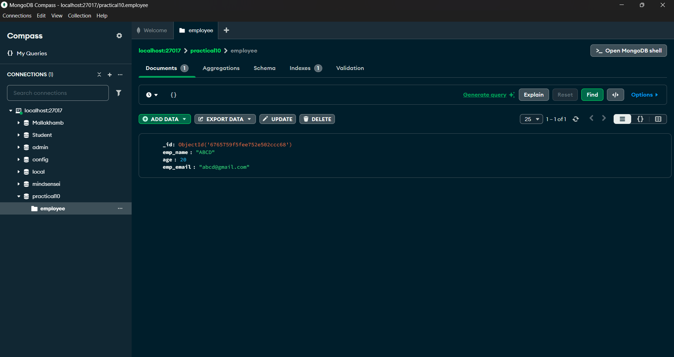

Delete Operation:

1. Navigate to the employee collection within the practical10 database.

2. Locate the document you want to delete by using the Filter box

3. Once the document is displayed, hover over it and click the Trash Bin icon (Delete Document button)

on the right side of the document.

4. A confirmation popup will appear. Click Delete to confirm the operation.

5. The document with emp_name: ABCD will be removed from the collection.

After deleting:

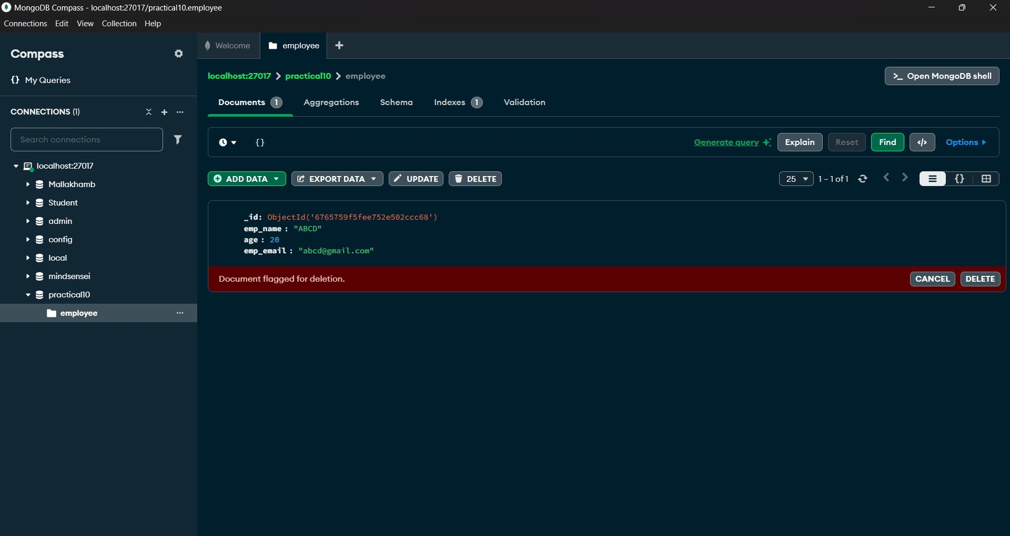

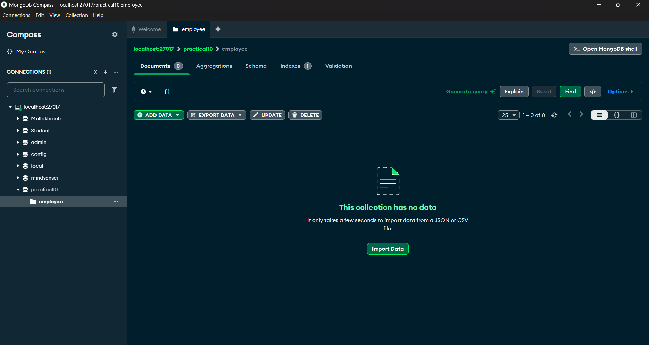

**Observation**:

1. MongoDB Compass provides an intuitive interface to perform CRUD operations without requiring

complex queries.

2. CRUD operations are the foundation for managing data in MongoDB, and these operations allow for

dynamic and scalable database management.

3. The BSON structure of MongoDB makes it easy to